Computer Architecture

Mid Term Exam

Name: ________________________

Instructions:

1. You can consult your notes but cannot ask for help to other students.
2. Calculators are allowed.
3. Time allowed is 1 hour 30 minutes. Marks will be deducted for late submission.
4. Total weightage of this exam is 30 marks.

Figure

Q. 1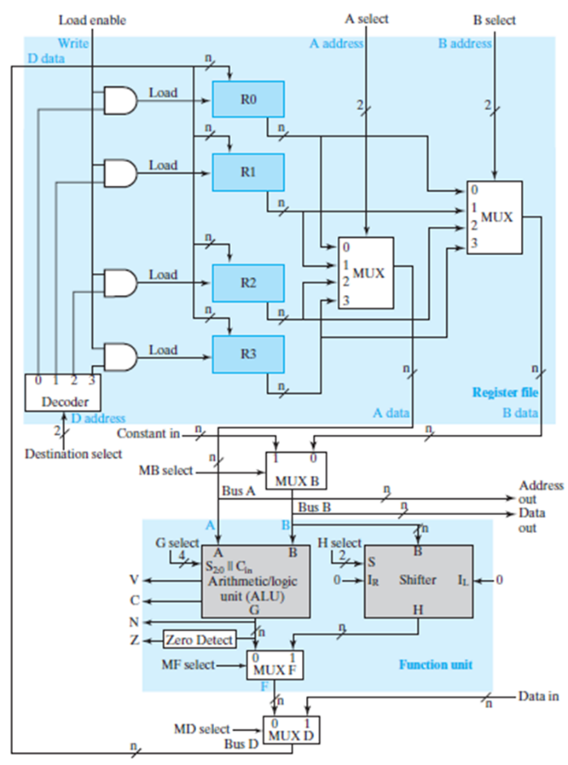 Refer to figure 1 and describe how this CPU will do memory operation (reading from memory and writing to memory? (2 marks)

Q. 2 Refer to figure 1 and describe the function of control signals Load Enable and Destination Select? (2 marks)

Q. 3 Refer to figure 1 and mention the changes in terms of control signals that need to make to have 8 registers? (3 mark)

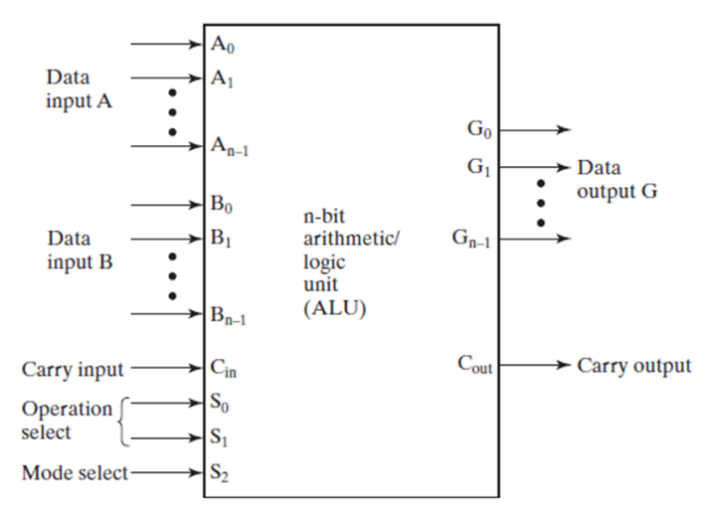

Figure

Q.4 Refer to figure 2 and relate the signals in figure 2 with signals in figure 1. Example is given below (4 marks)

|  |  |
| --- | --- |
| Figure 2 Signals | Figure 1 Signals |
| Data input A | Bus A or A |
| Data input B |  |
| Carry input |  |
| Operation select S0 |  |
| Operation select S1 |  |
| Mode select |  |
| Data output G |  |
| Carry output |  |
|  |  |

Q.5 What binary values are required on inputs Cin, S1 and S2 to subtract number “B” from number “A” in figure 3? (2 mark)

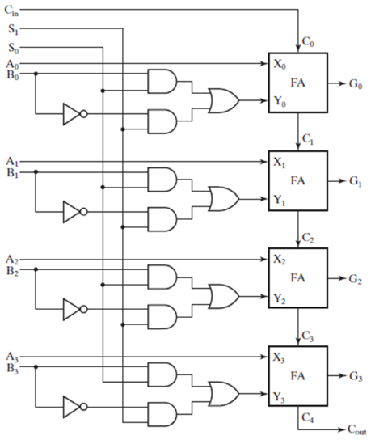

|  |  |
| --- | --- |
| Signal | Value |
| Cin |  |
| S1 |  |
| S2 |  |

Figure

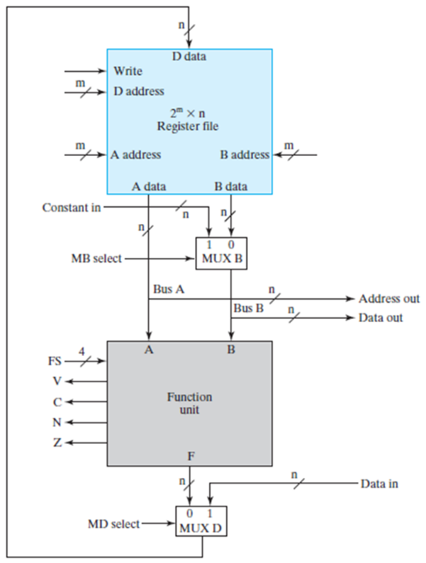

Figure

Q.6 Refer to figure 4 and answer below (4marks):

A. For having a 16 registers with each register of 16 bits, how many flipflops would be required? __________

B. For having a 16 registers with each register of 16 bits, how many bits would be required in B Address? ___________

C. How many different functions can be done by the Function Unit? ___________

D. The purpose of Mux D is _______________________________________________________.

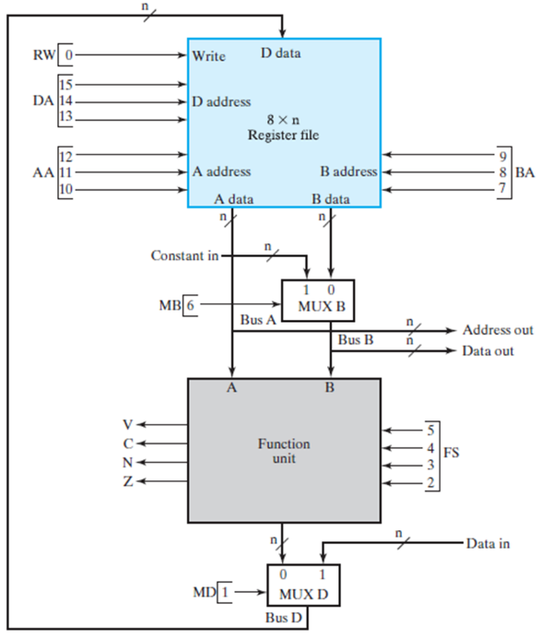

Figure

Q.7 Refer to figure 5, write the control word for the following instructions (6 marks)

R3 = R2 + R1

|  |  |  |  |  |  |  |  |  |  |  |  |  |  |  |  |
| --- | --- | --- | --- | --- | --- | --- | --- | --- | --- | --- | --- | --- | --- | --- | --- |
|  |  |  |  |  |  |  |  |  |  |  |  |  |  |  |  |

R4 = R6 – R5

|  |  |  |  |  |  |  |  |  |  |  |  |  |  |  |  |
| --- | --- | --- | --- | --- | --- | --- | --- | --- | --- | --- | --- | --- | --- | --- | --- |
|  |  |  |  |  |  |  |  |  |  |  |  |  |  |  |  |

Q.8 What is the purpose of register “PC” and how it works (3 marks)?

Q.9 Explain the purpose of following instruction format and how it works?

